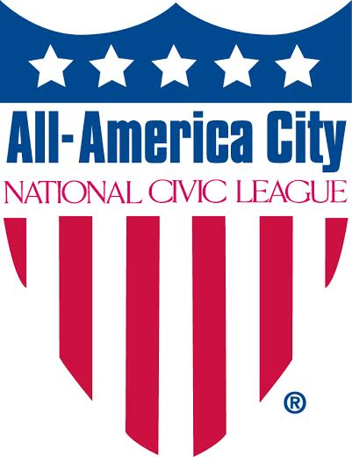
2025 All-America City Award Application

Theme: Strengthening Environmental Sustainability through Inclusive Community Engagement

Community Information

Community name and state: Carrboro, North Carolina

Your community is applying as a: ☐ Village ☒ Town ☐ Tribe ☐ City ☐ County ☐ Region

If applying as a region, name participating communities: Click or tap here to enter text.

Has your community applied before? ☐Yes ☒No If Yes, which years: Click or tap here to enter text.

Has your community been a Finalist before? ☐Yes ☒No If Yes, which years: Click or tap here to enter text.

Has your community been an All-America City before? ☐Yes ☒No If Yes, which years: Click or tap here to enter text.

Contact Information

All-America City Award contact (primary contact person available throughout competition & follow-up):

Name: Catherine Lazorko Title (if any): Communication and Engagement Director

Organization/Government/Other: Town of Carrboro

Address: 301 W. Main St. City, State, Zip: Carrboro, NC 27510

Phone (business/day): 919-918-7314 Mobile Phone: 919-265-7516

E-mail Address(es): clazorko@carrboronc.gov

If named a finalist, your community will receive a complimentary membership (or membership renewal if an AAC application was submitted last year) to the National Civic League for one year. To whom should this membership be directed?

Individual’s Name: Patrice Toney

Organization: Town of Carrboro

Address: 301 W. Main St.

City, State & Zip Code: Carrboro, NC 27510

Phone Number: 919-918-7315

Email: ptoney@carrboronc.gov

We agree to follow the National Civic League’s rules regarding use of the All-America City Award logo, a registered trademark of the National Civic League. We allow the League and the All-America City Award to share this application and the information enclosed in it with League and AAC networks to promote the work of our community. If we are named an All-America City, we agree to conduct a post-AAC conference call or regional forum for the AAC network that features our projects. If named a finalist, we understand and commit to either raising the money or covering the cost of sending a community delegation to attend and compete in the three-day Awards Event and Conference. In a pay-it-forward spirit, if named a finalist or All-America City, we agree to consider supporting AAC through a National Civic League membership for a minimum of the next three years.

Signature:

X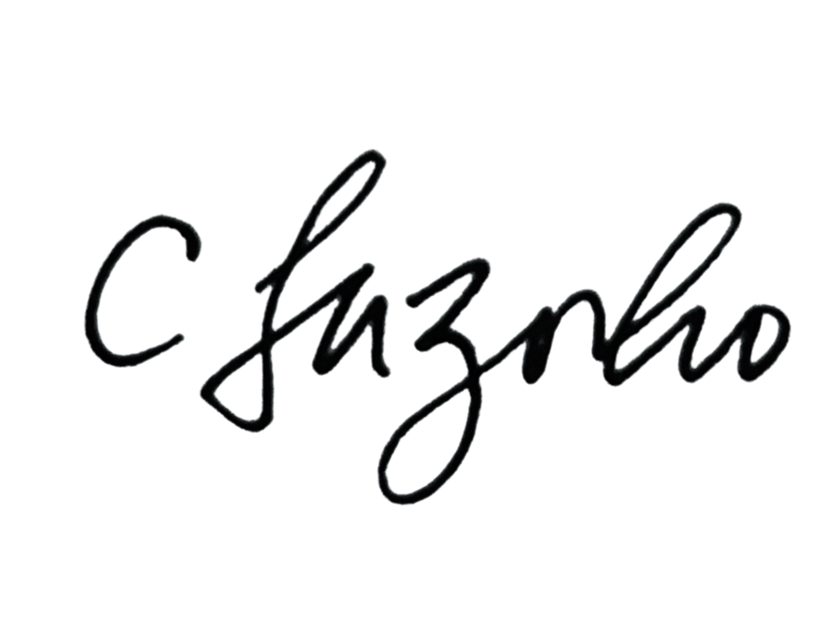

Date: March 6, 2025

Name: Catherine Lazorko Title: Communication and Engagement Director

Community Statistics and Map

Note: Use the most up-to-date statistics possible for your town, city, county, or region (source suggestions: U.S. Census Bureau, State Department of Economic Security, State Department of Finance, Department of Public Health, and local school statistics).

POPULATION (most recent Census): 21,312

POPULATION PERCENTAGE CHANGE 2010-2020 (indicate + or -): 8.7% +

RACIAL/ETHNIC POPULATION BREAKDOWN:

White 67.3%

Hispanic or Latino (of any race) 11.6%

Black or African American 13.3%

Asian 7.9%

American Indian and Alaska Native (AIAN) 0%

Mixed Race 7.6%

Other %

PERCENTAGE OF FAMILIES BELOW POVERTY LEVEL: 11.3%

UNEMPLOYMENT RATE: 2.9%

PERCENTAGE OF HOME OWNERSHIP: 43.5%%

MAP

Please insert a state map (8.5” x 11”) with your community clearly marked. Include as an attachment if unable to insert.

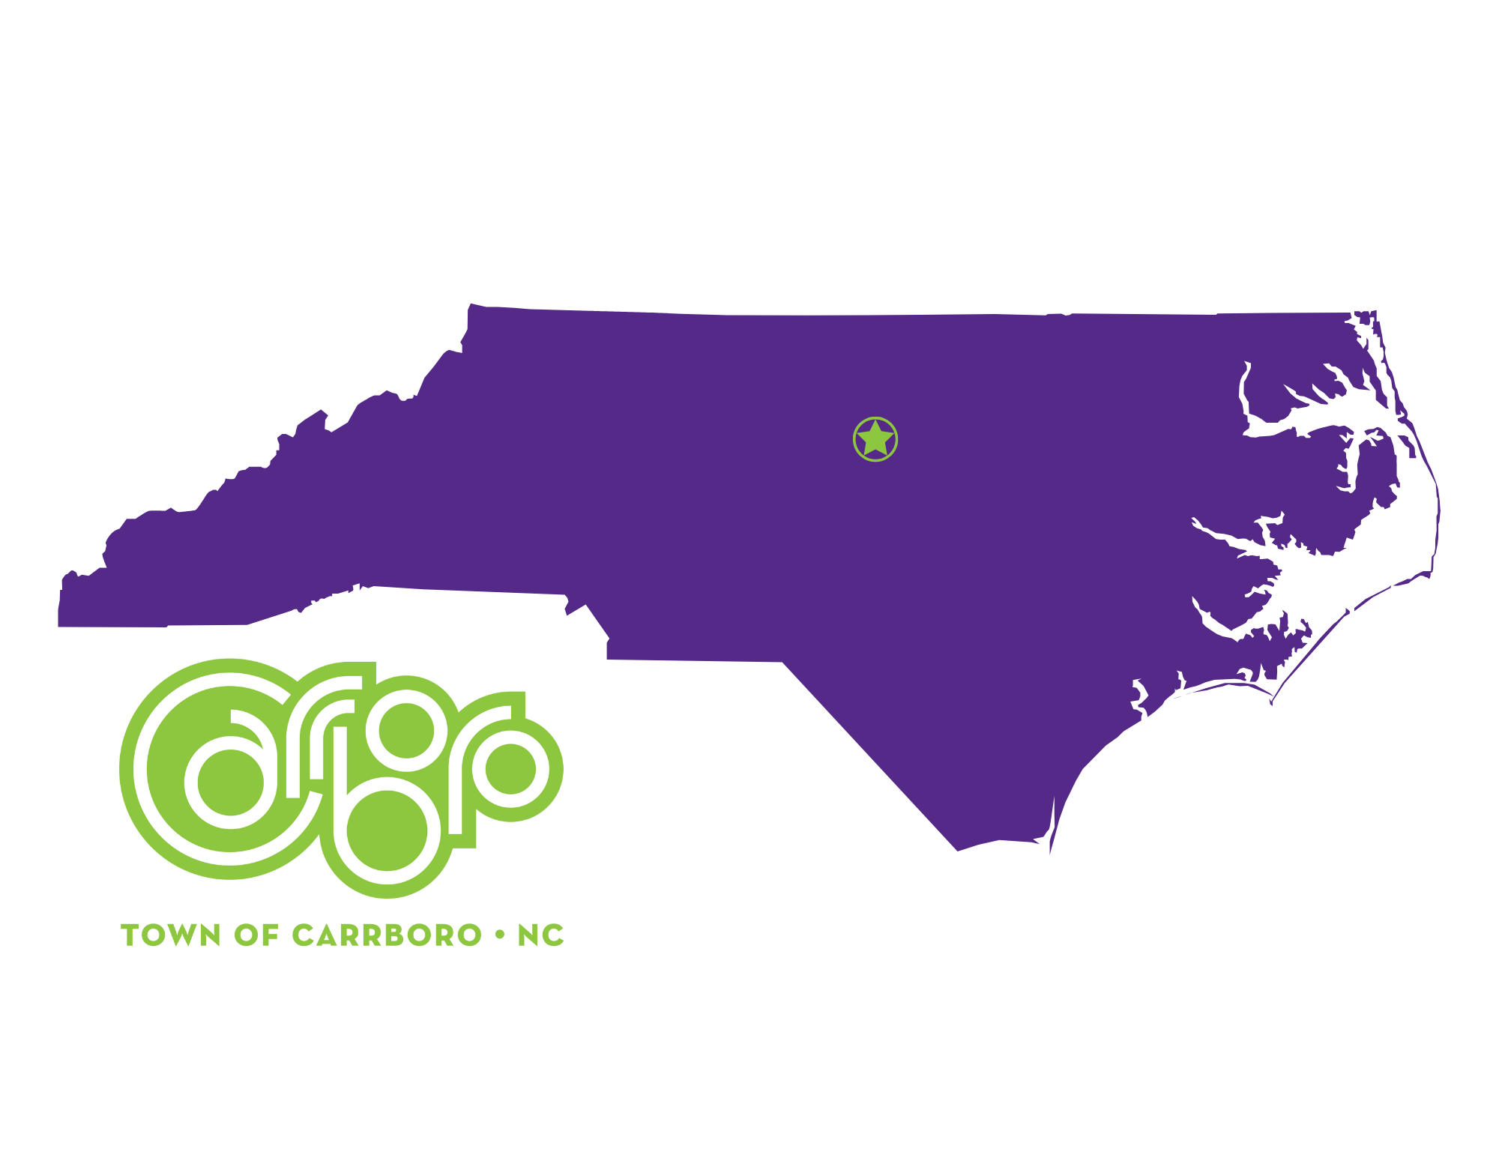

PART I: Tell Your Community’s Story

More than 20,000 people call Carrboro home. The community encourages creativity and innovation, from its many arts festivals to Farmers' Markets and everything in between, Carrboro strives to be a place where folks from all walks of life can live, work and create together.

Carrboro has the highest population density in North Carolina. Spanning 6.5 miles, the town as a population of 3,368 people per square mile – making it the highest population density in North Carolina. Nestled in the Piedmont region in the center of North Carolina, Carrboro is located directly west of Chapel Hill, home of the UNC flagship campus.

Over the years, the Town of Carrboro has taken many progressive steps to create a welcoming, sustainable, and diverse community. It was the first North Carolina municipality to elect an openly gay Mayor in 1995 and the first local government in the state to grant domestic-partner benefits to same-sex couples. To acknowledge the ties of the town’s namesake to racial segregation and other truths about its history, Carrboro began installing “truth plaques” in 2019 at Town Hall and other historical sites. In 2023, Barbara Foushee was the first Black woman elected as mayor of Carrboro and the second Black person to hold the office.

In 2020, the Carrboro embarked upon a comprehensive planning process – the first in over 20 years. This plan established Carrboro’s two core foundations – racial equity and sustainability/climate action. The Office of Racial Equity was established in August 2022 with the appointment of a Chief Race and Equity Officer. In December 2024, a new Office of Sustainability was created to achieve the Town’s ambitious climate action goals.
Since the 2022 adoption of Carrboro Connects, the Town's comprehensive plan, staff and Town Council have begun implementing its priority policies and projects. In 2024, the Council adopted the town’s first Language Access Plan. In 2025, Carrboro is developing a new Carrboro Downtown Area Plan while also updating its Land Use Management Ordinance.
In 2025, leadership is focused on municipal infrastructure. While we are celebrating the recent opening of the largest public building in the history of Carrboro with the Drakeford Library Complex, a jointly owned facility with Orange County, we are challenged by maintenance and upgrade needs to existing municipal buildings. An aging Carrboro Town Hall lacks an elevator and basic ADA compliance, and the Carrboro Century Center, which houses the police department, is also in need of renovation. In addition, community members are eager to see greenway expansion, new sidewalks, and a multimodal network.
Carrboro is intent on pursuing the strategic directions set by the foundational pillars of racial equity and climate action to build a thriving town. Whether addressing the urgency of climate change or overcoming the legacy of racial and ethnic barriers, the spirit of our community is expressed across a broad spectrum of interests, passion and expertise. The way we will respond to challenges undoubtedly may change our town long into the future. We hope to emerge a stronger, happier and more equitable community.

PART II: Describe the Strength of Your Community’s Civic Capital

For the first few decades after its incorporation, Carrboro maintained a distinct identity as a small mill town on the other side of the tracks from Chapel Hill. Carrboro’s population began to increase during the 1960s due to growth occurring at the University of North Carolina and supporting businesses. This new population included a large number of students who would play an important role in shaping the Town’s politics and culture.
Carrboro has developed an eccentric culture and a reputation as one of the most accepting communities in the South, welcoming people from all walks of life and all parts of the world.
Carrboro has a rich history with historically Black communities, particularly Northside, which was founded during the construction of UNC in the 1800s, and other neighborhoods like Pine Knolls and Tin Top.
In the early 1990s Carrboro experienced a large influx of Latino immigrants. The Hispanic population increased by 936% between 1990 and 2003 making up 12% of the Carrboro population. Founded in 1992, El Centro Hispano is a local Latino nonprofit organization dedicated to strengthening the community, building bridges and advocating for equity and inclusion for Hispanics/Latinos in the Triangle.
Carrboro has welcomed refugees from all over the world including people from Syria, Afghanistan and the community from Burma. The Refugee Community Partnership is a local organization that helps to connect people to the resources they need and works to eliminate barriers to access.
Foundational Pillars – Race and Equity and Sustainability/Climate Action

The Town Council has established two foundational pillars for the Town of Carrboro, which are Race and Equity and Sustainability/Climate Action.

Achieving racial equity and advancing opportunities for all is an ongoing and important effort in the Town of Carrboro, which adopted a comprehensive plan in June 2022 that requires all goals and projects to be evaluated through a lens of race and equity advancement. The Town is a six-year member of the Government Alliance on Race and Equity (GARE) and involves all employees in regular DEI training and conversations.
The Town Council’s adoption of the Racial Equity Action Plan provides a blueprint of our work moving forward. The direction also includes evaluating policies, practices, procedures, and service delivery through REAL analysis.
Carrboro Race and Equity Vision Statement:
The Town of Carrboro envisions being a community where race does not determine outcomes, and all have equitable opportunities and resources. We envision a time when participation in community events, programs and advisory boards represent community demographics. All will feel safe, secure, and know their voice is valued. We strive to be an inclusive and open-minded organization that has a culture created by its diverse staff, which serves the public through a social (racial) justice lens.

The Town Council initiated considerations of the impact on race and equity in October 2018 when it unanimously voted to formally begin race and equity work. In November 2018 the Town joined the Government Alliance for Race and Equity (GARE). The inaugural Race and Equity Officer was appointed and the Town developed a leadership core team. That core team participated in a cohort of communities across North Carolina, which culminated in a train-the-trainer model that has resulted in core team members training every Carrboro staff member. The Town started conversations with its partners in Orange County to create a county-wide message and plan. Every jurisdiction in Orange County is now a member of GARE. Through this process, Carrboro’s Vision statement on race and equity was formed and the logo created:

Carrboro strives to be an inclusive and open-minded organization that has a culture created by its diverse staff, which serves the public through a social (racial) justice lens. GARE training was provided to the Carrboro Connects Task Force and consultant team as part of this process and continues to be provided to all Town Advisory Boards and Commissions. This peer-to-peer training provides a welcoming atmosphere so that members can reflect and process the information in a deep, introspective manner.

In addition to Carrboro's participation in GARE, the Town is also an active member of One Orange, a county-wide initiative to provide a race and equity framework for reviewing government actions. The Town and its partners adopted The One Orange Countywide Racial Equity Framework in January 2022. One Orange Racial Equity Framework "The One Orange Countywide Racial Equity Framework: Catalyst for Moving Forward is designed with the commitment of uncovering and addressing implicit biases in our jurisdictions to ensure that race no longer can be used to predict life outcomes in the Orange County community.

Since August 2020, a multijurisdictional workgroup [the Towns of Carrboro, Chapel Hill, and Hillsborough and Orange County] collaborated on this framework using GARE methodology and listening to the community.

As part of the Town's participation in GARE and the urgent need to address disparities and create an equity-focused organization and community, each Town department uses the Racial Equity Assessment Lens (REAL) to evaluate policies, practices, procedures and services.

The Town's commitment to advancing race and equity can be seen throughout the Carrboro Connect Comprehensive Plan. Examples include:

- Affordable Housing: Promote the availability of affordable housing for both homeowners and renters; provide assistance toward the preservation of affordable housing units; and work with Orange County to provide services and housing for homeless/unsheltered individuals and families.
- Climate Action & Environment: Ensure distribution of environmental burdens and access to natural areas and ecosystems to be equitable across race, income, and ability, especially in neighborhoods that have been historically underserved.
- Transportation & Mobility: Address and reverse disparate impacts of past transportation decisions.
- Green Stormwater Infrastructure, Water & Energy: Invest in green infrastructure with a focus on Carrboro’s BIPOC, lower-income and multiple abilities populations.
- Economic Sustainability: Create a more inclusive economy and encourage more racial equity in business growth and start-ups; support existing and attract new businesses that include a range of BIPOC, gender, ethnicities and multiple abilities.
- Recreation, Parks and Cultural Resources: Prioritize access for immigrant, BIPOC and other underserved communities while planning for new facilities and celebrate the diversity of Carrboro through cultural events, programming, artwork and stories.
- Land Use: Promote excellence in design that meets the diverse range and cultures expressed in the built environment; promote the development of affordable housing through modifications in the land use ordinance; and identify opportunities for affordable housing at key nodes and corridors throughout the Town.
- Public Services and Communication: Expand equitable community participation in the decision making and implementation of Town goals and policies.

Climate Action and Sustainability

The second foundation of the Town of Carrboro is climate action. In 2024, the Town established a Chief Sustainability Officer who works alongside the Chief Racial Equity Officer to implement the strategic goals for the community across these two foundational pillars.

The Town has been and continues to be a national leader in its efforts to address climate change with bold, actionable plans in place. Carrboro was one of the first communities of its size to commit to addressing climate change in a comprehensive manner.

In 2009, the Carrboro Board of Aldermen passed a resolution committing the Town to reduce emissions of greenhouse gas emissions that are causing global climate change. In 2014, Carrboro developed a plan focusing on the Town’s municipal operations, held three forums regarding climate action, and launched a Task Force to develop the Community Climate Action Plan, which was first released in 2017.

The Community Climate Action Plan (CCAP) goes beyond municipal emissions and focuses on actions the broader community can take to reduce Greenhouse Gas (GHG) Emissions. In 2020, the Plan was updated to establish a goal of 80% reduction in GHG by 2030 as compared with 2010 levels. When the experts say “if we don’t act now the effects will be irreversible,” Carrboro takes that very seriously.

New Avenues for Public Participation

Carrboro has set a high bar for civic engagement, incorporating public input into all Town decisions and processes. While this is true, it remains a challenge, in many communities, to reach beyond the usual suspects and hear from the full range of residents. To be successful, outreach efforts are intentionally designed to go the extra mile and reach out to all members of the Carrboro community, including groups that may have not been involved in the Town’s activities in the past. The Town of Carrboro pursues goals of an inclusive and equitable community by creating new avenues for public participation through a variety of innovative methods, many of which stem from the Inclusive Carrboro Communication and Community Engagement Plan.

From community block parties held at apartment complexes named Carrboro In Motion/Communidad en Movimiento, a network of outdoor Town Information Centers (outdoor message kiosks) for non-digital outreach, and close working relationships with community nonprofits like El Centro Hispano, the Chapel Hill-Carrboro branch of the NAACP, and the Refugee Community Partnership, the Town has led successful engagement processes for a variety of local issues. Staff pursue non-traditional methods of outreach to inspire community involvement.

Toward its goal of equitable engagement, staff work to reach those who are most often marginalized in community conversations. Town staff regularly work with El Centro Hispano and the Refugee Community Partnership to conduct canvassing to increase survey participation among immigrants and refugees. Outreach is also made in the town's historically Black neighborhoods with a staff team going door-to-door to drop off literature bags or wall calendars.

The Town of Carrboro’s growing network of outdoor Town Information Centers advance a goal to find new methods of non-digital outreach and to build relationships by going where the people are. This program began during the unprecedented times of COVID, when Town staff looked for new avenues to provide critical news such as health guidance, food distributions and emergency housing assistance to the community. We recognized that many of our residents do not have digital access, or are not plugged into social media or town emails.

The outdoor kiosks display flyers (as much as possible with bilingual English-Spanish postings) with information that promotes services, job and training opportunities, and events like festivals and community activities. Residents are also free to use the boards to share information.

The Town began its neighborhood message network on Christmas Eve 2020 at the Rocky Brook Mobile Home Park. In 2021, three more outdoor kiosks were installed. In 2025, the number of outdoor kiosks has expanded to 11 and includes mobile home parks, public housing neighborhood, and town parks.

Town staff reached out to managers of apartment complexes, mobile home parks, and a public housing community with a query of interest. Locations for the initial message centers were selected based on community demographics and resident needs, targeting underserved areas.

Looking Forward

No community had it easy during the pandemic and Carrboro was no exception, but lessons about our community’s resilience emerged from this challenging time period.

From 2020-2021, during the community engagement for the Carrboro Connects Comprehensive Plan, communities around the world shifted many work and social activities into a virtual space.

Carrboro Connects had to do the same, and quickly realized some of the benefits of virtual communications: it may be easier for some to participate from home via phone or computer; there is no need to find transportation or childcare; folks can log on for as much time as they have; participation can be with cameras on or off, via the chat, or by listening; and you can have multilingual meetings using Zoom’s interpretation tool with a live translator and breakout rooms in different languages. And we tested many new methods of outreach.

Community resilience is the ability to prepare for anticipated hazards, adapt to changing conditions, and withstand and recover rapidly from disruptions. As Carrboro faces new challenges in 2025 and beyond, we anticipate that long-established relationships with residents and strong collaboration between local government and community partners will weather us through challenging times.

PART III: Describe Three Community-Driven Programs
Project One: Carrboro in Motion Fest/Festival de la Comunidad en Movimiento (CIM)

Despite the Town of Carrboro’s best efforts, often the perspectives and viewpoints of renters are underrepresented in typical engagement opportunities including public hearings, land use and local area planning discussions, surveys, and open house events. About 58% of Carrboro’s residents rent their homes.

Carrboro in Motion Fest/Festival de la Comunidad en Movimiento (CIM) is designed to promote regular and effective participation with communities. At these neighborhood events, residents join neighbors, community, Town employees and elected public officials in social time, information sharing, and an opportunity to hear from residents in a relaxed setting. These events support the Town’s goals for equitable access and the opportunity for equal input by going where the people are and inviting them to participate in a free, government-sponsored event.

Carrboro rotates these community block parties where we see a high percentage of emergency housing assistance applications. Here the residents are majority multiracial and multicultural populations. By reaching out to renters through free and fun family events in their communities, we will have a better chance of building relationships that will lead to increased civic participation, as well as access to services and hearing those silent voices about living experiences, needs and service delivery.

Carrboro in Motion aims to bring people and community assets together to improve lifestyles by:

- Creating awareness of services offered by local government and non-profit agencies
- Encouraging health and wellness
- Promoting environmentally friendly habits and lifestyle
- Supporting opportunities for conversation and dialogue
- Increasing neighbor-to-neighbor participation and engagement with local government
- Creating a welcoming spirit of community where everyone belongs
- Inspiring leadership through opportunities to serve as neighborhood liaisons, apply for advisory boards and commissions

Residents come out for a Zumba class; a bike fix-it station where numerous bikes are repaired and biking needs identified; a Chapel Hill Transit bus; a mobile health unit; storytime readings for children from librarians; and oftentimes, Latin dance performances from Takiri Folclor Latino, a local dance group. Participating at the CIM events are Chapel Hill Transit, El Centro Hispano, Carrboro Police Department, Carrboro Fire-Rescue, Orange Literacy, RedRidge NC BikeShare, Bike Carrboro, the Orange County Public Library, Orange County Department of Health, Orange County Department of Social Services, and other non-profit partners. We have recently added a sno-cone truck, which has been a great draw for families.

Available at past events have been free winter coats, bags of fresh food produce, and refreshments of hot cider and biscuits. Orange Literacy has provided information about free English classes at no cost with free childcare and other options. Orange County Public Library has signed people up for library cards. The Orange County Health Department provides applications for Medicaid and offers other services.

The Carrboro Planning Department encourages walking, biking and riding the bus. Carrboro’s Communication and Engagement team shares info about services and events; newcomer information; advisory board opportunities; and encourages participation in surveys and engagement topics. Carrboro’s Recreation, Parks and Cultural Resources has supplied a party trailer outfitted with tables, chairs and outdoor games for children. Our Climate Action Team sets up interactive tables to educate about the natural environment and encourage sustainable practices such as composting.

Carrboro in Motion events:
- 2022 - Estes Park Apartments and Carolina Apartments.
- 2023 - Berkshire 54 Apartments, Royal Park Apartments, Carolina Apartments, and Estes Park Apartments.
- 2024 - Estes Park Apartments, Collins Crossing Apartments and Royal Park Apartments, and then expanded to business centers at the Willow Creek Laundromat and the Fitch Hardware & Lumber Parking Lot.
- 2025 – We have plans for six events beginning on March 15.

Last year, our team was invited by apartment complex managers to participate in barbecues/pool parties organized for residents. Some property managers have told us that they were inspired to host these pool parties by Carrboro in Motion. These are particularly well attended and great partner events.

Carrboro in Motion Fest/Festival de la Comunidad en Movimiento stems from a stated Council interest to see the addition of Town-sponsored block parties in neighborhoods. Council members attend the block party events and support the resources and funding necessary to make these programs possible. The annual cost for the program is approximately $5,000, which covers interpreters, swag and refreshments.

Our outreach with residents who live in apartment complexes has led to offshoot programs including the printing of an annual bilingual wall calendar. The calendar features the town’s free festivals and special events with local services resources and contact information.

In 2025, we completed delivery of wall calendars to all the apartment complexes that we visit through Carrboro In Motion. We hang the calendars from a bag distributed on the doorknobs. This is another touchpoint from the Town – “We see you! Happy New Year!” An interdepartmental staff team worked together on calendar preparations and delivery. Nearly 2,000 calendars were distributed to residents at apartment complexes, a public housing neighborhood, mobile home communities and historically Black neighborhoods. The entire effort took several days.

Through these various touchpoints, we hope to encourage relations and participation in local government, such as serving on an advisory boards, becoming a neighborhood liaison, and involvement in local issues. We are developing a neighborhood liaison program that will be a natural connector with Carrboro in Motion. We are collecting data on the number of people who attend and requesting their voluntary demographic information through large posters where they can add stickers by various fields to indicate age, race, ethnicity and other information.

The success or failure of many traditional civic engagement techniques is based on numbers: the number of meetings/events, counting the people who attended. However, those numbers tell us little about what happened. Were new connections made? Were the voices of the most marginalized heard? Did people come away with a new understanding of each other? We believe that Carrboro In Motion answers these questions with "Yes!" We look forward to building on the success of Carrboro in Motion. Relationships are developing. We are continuing our conversations.

Catherine Lazorko, Communication & Engagement Director for the Town of Carrboro, clazorko@carrboronc.gov

Project Two: Green Neighborhoods Grant Program

As part of its Community Climate Action Plan (CCAP) implementation, the Town of Carrboro offers the Green Neighborhoods Grant Program. Residents can receive up to $2,500 to complete a project that will either reduce greenhouse gas emissions, enhance ecosystem resiliency, or contribute to climate action awareness or engagement.

The program was initiated under the Community Climate Action Plan (CCAP) in 2017 to expand the Town’s existing climate action efforts and emphasize measures that community members can implement to help achieve greenhouse gas emissions reduction targets. The plan’s goal is to raise the community’s awareness and involvement in climate action and the enhancement of ecosystem resilience. In 2020, the Town updated the CCAP goals to recommend an 80% reduction of 2010 emissions levels by 2030. This was reaffirmed in the 2022 Carrboro Connects Comprehensive Plan. To achieve this goal, widespread community participation in every aspect of the plan is essential.

The Green Neighborhoods Grant Program seeks to benefit low-income households and residents of color by bringing neighbors together to pursue projects which will reduce greenhouse gas emissions and create natural areas that are more resilient to the impacts of climate change, ultimately benefiting the entire community.

Grant Program Goals
- Educate and empower neighborhoods to address climate change
- Build neighborhood capacity to engage in climate action
- Develop and enhance community and Town partnerships
- Leverage Town and neighborhood involvement and resources
- Distribute resources to low-income and communities of color who are disproportionately affected by climate change.

Eligible Projects

Projects that demonstrate shared benefits with a goal of reducing greenhouse gas emissions and/or contributing to ecosystem resiliency.

All projects must achieve the following:
- Reduce emissions, enhance ecosystem resiliency, or contribute to climate action awareness or engagement
- Be completed within six months of grant award
- Be initiated, planned, and implemented by community members
- Obtain Town permits required for construction, if applicable.
- Any contractors must carry required insurance.
- Group/fiscal agent must obtain adequate liability insurance if deemed necessary

Town of Carrboro staff and advisory board members review and evaluate grant applications according to criteria of racial equity and environmental justice, project impact, project planning and design, neighborhood participation and support, project engagement, finances and whether the project is from a first-time applicant.

Examples of past projects awarded include:
- Strayhorn Community Garden -- Restore the Strayhorn homeplace to its historical botanical splendor by planting native pollinator gardens, native carbon-sequestering grasslands, and a community vegetable garden. A community project which will include neighbors in contributing to the selecting, planting, and maintaining the gardens while learning about the history of Black Carrboro and the contributions of the Strayhorn family.
- Pacifica Vermicomposting -- Promote vermicomposting (worm composting) for community gardens, intentional communities, and individuals through an introductory and follow-up workshop, providing materials to get started, and continuing consultation services. The program is committed to ensuring that they reach low-income households and residents of color throughout Carrboro.
- Berryhill HOA Climate Action and Resilience - Planting native trees and shrubs (pollinator friendly) in communal area.
- Barred Owl Creek Composting Pilot -- To kick-start the program, hosting a neighborhood event at the compost collection site and educating attendees about best practices for composting. Representatives from Compost Now and Orange County Solid Waste will be invited to participate, and the event will use only compostable materials. The composting service runs for 10 months. During this time, project group provides regular updates, education, and encouragement to all Barred Owl Creek residents through a monthly newsletter on the neighborhood listserv.

Carrboro also provides project ideas to applicants, including:

Community Integration, Awareness/Engagement
- Design educational campaigns–e.g., social media, yard signs
- Create public art related to climate action
- Design and implement educational youth programs related to climate action
- Create a campaign to increase awareness and community engagement with additional climate-related resources and funding opportunities (e.g., Inflation Reduction Act Solar Tax Credit, Low-Income Home Energy Assistance Program, the B.W. Wells Stewardship Fund, etc.)

Building Energy Efficiency
- Create educational materials to help neighbors save energy in their homes
- Create program to help neighbors obtain energy audits
- Create neighborhood LED lightbulb replacement program
- Change out hot water heater in HOA clubhouse

Transportation
- Create neighborhood shared bicycle program
- Develop bicycle maintenance or safety kits for neighborhood use
- Design and promote weekly bike/walk to school days
- Coordinate neighborhood carpool program

Renewable Energy
- Create educational campaign for neighbors to pursue solar

Ecosystem Protection & Enhancement
- Plant or replace trees, create a community rain or pollinator garden
- Create a neighborhood invasive species removal group
- Set up a neighborhood composting site
- Organize neighborhood waste reduction initiatives
- Green stormwater infrastructure
- Stream repair or buffer restoration projects

Food Choices
- Plant a community garden or build a community greenhouse
- Hold a neighborhood climate friendly food event
- Create a campaign to educate neighbors on making climate friendly food choices

In summary, Carrboro has awarded grants to 16 projects over two funding cycles. In 2025, the sustainability team anticipates funding up to 10 projects. The community is passionate and deeply engaged in climate action. It is a core value of Carrboro and a cornerstone of the Town’s Comprehensive Plan.

Anecdotally, one grant recipient from the Fairoaks neighborhood noted that the Green Neighborhoods grant has built community in their neighborhood. As new neighbors learn about and start to use new drop-off compost bins, they are building friendships and connections that have helped them engage in other Town issues. The neighborhood champions of this project reached out to other Carrboro neighborhoods and encouraged them to apply for similar grants. Now the Town has four neighborhoods with compost drop-off stations!

Amy Armbruster, Chief Sustainability Officer for the Town of Carrboro, aarmbruster@carrboronc.gov

Project Three: Bolin Creek Watershed Restoration Program

What began more than eight years ago as an erosion issue spanning private properties in the Bolin Forest and Forest Court neighborhoods in Carrboro, evolved into a powerful solution to address very real issues related to property, public safety, and quality of life for affected private residents.

The Bolin Creek Stormwater Collaborative, of which the Town of Carrboro Stormwater Division played a central role, implemented a stormwater solution spanning across multiple HOA-owned properties and private properties. The resulting project exemplifies sustainable practices, community involvement, and innovative engineering -- and demonstrates the creative use of resources to overcome obstacles.

The project traces back to 2006 when the Towns of Carrboro and collaborated with the Environmental Protection Agency (EPA) and NCDEQ to form the Bolin Creek Watershed Restoration Team. In 2012, through EPA-319 grant funding, a nine-element Watershed Restoration Plan (WRP) was developed for the entire Bolin Creek watershed. The WRP provided extensive details for all the impacts, pollutants, threats, and stressors within the watershed. Some of the key/primary stressors identified include stream erosion and instability, riparian buffer disturbance, floodplain alteration, and nutrients.

By 2015, a small group of local homeowners and HOAs began working together with community members and local government agencies to identify and address local stressors within this subswatershed of Bolin Creek. Their focus was on three acres of HOA-owned parcels with a legacy erosion issue. Community members who did not fully understand stormwater management practices pursued partnerships and collaborated to find solutions.

In 2021, this group was closely connected and focused on these issues when the North Carolina Department of Environmental Quality (NCDEQ) awarded an EPA 319 grant. The funding was directed to the Town of Carrboro and its partners to construct two Regenerative Stormwater Conveyances (RSCs) spanning three Homeowner Association (HOA) properties.
The Carrboro Stormwater Collaborative completed the Regenerative Stormwater Conveyance (RSC) to prevent erosion and keep sediment and nutrients from flowing into Bolin Creek. This RSC is a natural design stormwater treatment device with a cascading series of in-channel rock structures and pools, adjacent sandy berms, and vegetative banks. Native plants and riparian seed are an important part of the RSC, as the roots not only use the nutrients and water but also filter out pollutants before they enter the creek.

Several years of community meetings were held within and across the three HOAs to understand the problem and to find a path forward address the legacy erosion and damage to private property. Two neighborhood volunteers led HOA and community conversations, engaged community partners, and worked with the Town to develop the vision, plan and to promote educational and engagement components.

Fifteen community partners were recruited and submitted letters of support outlining their agreement to contribute cash and in-kind activities to the project (3 HOAs, 7 homeowners, OWASA, NC State Extension Service Water Quality Specialist, Carrboro Stormwater Advisory Board, Orange County Soil and Water, Orange County Stormwater, Friends of Bolin Creek, Carrboro High School environmental teacher, and UNC Eco Lab). The three HOAs and seven private homeowners all signed Memoranda of Agreements (MOAs) for the RSC to be installed on their private property and their agreement to work together to maintain the RSC in perpetuity.

Significant community involvement occurred through community meetings and emails, HOA board meetings and actions, community educational opportunities, and volunteer workdays. Community meetings were held by Town staff, the Design Engineer, and the Construction Contractor to share renderings, secure access agreements, discuss the timeline and logistics with homeowners, and troubleshoot concerns as they arose.

Seven community events were organized:

- Three community educational workshops were led by NCSU Extension water quality specialist to showcase how homeowners can reduce stormwater runoff.
- A small-tree removal workday was held prior to construction with 20+ neighborhood volunteers.
- Two planting workdays were held with 150+ volunteers planting over 1,300 native plants. The volunteers were from the three affected neighborhoods, Carrboro High School, Friends of Bolin Creek, Town Council, and a resident who heard about it through Town promotions.
- A celebration of the project was held at the Carrboro Century Center in April 2024 where residents and other neighborhoods were invited to learn about resources available to address stormwater concerns. A high-quality video/documentary of the project, created by a UNC/Town intern, was featured to share interviews with various members of the design team and community volunteers.

HOA engagement was essential to establish neighborhood ownership for long-term maintenance:

- Cross-HOA board meetings were held to agree on principles; establish written legal agreements to jointly maintain the RSC, a customized Operations & Maintenance Manual, a maintenance easement with private homeowners; and record these various documents with the Orange County Register of Deeds.
- The three HOAs agreed to establish reserve funds for maintenance and restoration of the RSC as needed and to contract with the Design Engineer to annually inspect the RSC and guide any maintenance/repair needs.
- A core group from the three HOAs watered, weeded, and installed deer protection for newly established plantings, coordinated with OWASA (the Orange Water and Sewer Authority) to establish a mowing schedule/agreement for preventing damage to the RSC vegetation, and installed informational signs along the project site to create public awareness of and protect the improved stormwater conveyance channel.

This project is a powerful example of how local watershed improvements are possible when there's collaboration. The project has grown well beyond the initial vision. It serves as a model of how partnerships can generate ownership and momentum for community-driven watershed restoration. The project has built awareness, interest, action, and momentum for stormwater management at the local watershed level. The project helped the local community better understand that stormwater runoff does not care about property boundaries.

Recognizing the project’s success, the Town of Carrboro Stormwater Division along with collaborating partners received the Project of the Year Award from the 2024 American Public Works Association – North Carolina Chapter.

Debbie Shoffner, Stormwater Administrator for the Town of Carrboro, dshoffner@carrboronc.gov

End of Application. Thank you for submitting your All-America City Award Application!

