Community Information

Community name and state: City of Rancho Cucamonga, California.

Your community is applying as a:

____ Village ___ Town ___ Tribe X City ___ County ___ Region

If applying as a region, name participating communities: N/A

If applying as a neighborhood, name city: N/A

Has your community applied before? No

Has your community been a Finalist before? No

Has your community been an All-America City before? No

Contact Information

All-America City Award contact (primary contact person available throughout competition & follow-up):

Name: Nicole Dalton Title (if any): Community Affairs Coordinator

Organization/Government/Other: City of Rancho Cucamonga, California.

Address: 10500 Civic Center Drive City, State, Zip: Rancho Cucamonga, CA 91730

Phone (business/day): (909) 774-2016 Mobile Phone: (909) 841-1968

E-mail Address(es): Nicole.Dalton@CityofRC.us

If named a finalist, your community will receive a complimentary membership (or membership renewal if an AAC application was submitted last year) to the National Civic League for one year. To whom should this membership be directed?

Name: Nicole Dalton

Address: 10500 Civic Center Drive

City, State & Zip Code Rancho Cucamonga, CA 91730

Phone Number (909) 774-2016 Fax N/A

Email Nicole.Dalton@CityofRC.us

We agree to follow the National Civic League’s rules regarding use of the All-America City Award logo, a registered trademark of the National Civic League. We allow the League and the All-America City Award to share this application and the information enclosed in it with League and AAC networks to promote the work of our community. If we are named an All-America City, we agree to conduct a post-AAC conference call or regional forum for the AAC network that features our projects. If named a finalist, we agree to send a community delegation to attend and compete in the three-day Awards Event and Conference. In a pay-it-forward spirit, if named a finalist or All-America City, we agree to consider supporting AAC through a National Civic League membership for a minimum of the next three years.

Name: Nicole Dalton Title: Community Affairs Coordinator
Community Statistics and Map

Note: Use the most up-to-date statistics possible for your neighborhood, town, city, county, or region (source suggestions: U.S. Census Bureau, State Department of Economic Security, State Department of Finance, Department of Public Health, and local school statistics).

POPULATION (in year 2010 or most recent): 2019 - 179,412

Source/Date: CA Dept. Of Finance E-1 Population Estimates for Cities, Counties, and State.

POPULATION PERCENTAGE CHANGE 2000-2010 (indicate + or -): +22.7%

Source/Date: CA Dept. Of Finance E-1 Population Estimates for Cities, Counties, and State.

RACIAL/ETHNIC POPULATION BREAKDOWN:

White 57.3%

Hispanic or Latino (of any race) 40.9%

Black or African American 9.2%

Asian 12.3%

American Indian and Alaska Native (AIAN) 7.0%

Mixed Race 6.1%

Other 14.1%

Source/Date: U.S. Census Bureau, Census 2010 Summary File 1. Esri forecasts for 2019 and 2024 converted Census 2020 data into 2010 geography.

MEDIAN FAMILY INCOME: $87,357.00

Source/Date: U.S. Census Bureau, Census 2010 Summary File 1. Esri forecasts for 2019 and 2024 converted Census 2020 data into 2010 geography.

PERCENTAGE OF FAMILIES BELOW POVERTY LEVEL: 8.1%

Source/Date: U.S. Census Bureau, Quick Facts for the City of Rancho Cucamonga.

UNEMPLOYMENT RATE: 2.8%

Source/Date: State of CA Employment Development Department

POPULATION BREAKDOWN BY AGE GROUP (percentages, if available):

19 years old and under 24.7%

20-24 6.7%

25-44 30.8%

45-64 26.2%

65 and over 11.9%

Source/Date: U.S. Census Bureau, Census 2010 Summary File 1. Esri forecasts for 2019 and 2024 converted Census 2020 data into 2010 geography.

PERCENTAGE OF HOME OWNERSHIP: 61.4%

Source/Date: U.S. Census Bureau, Census 2010 Summary File 1. Esri forecasts for 2019 and 2024.

WORKFORCE DISTRIBUTION -- Name the three largest employment sectors (include military services and/or installations, if any) in your community and provide the percentage of total employed in each:

Education 18.7%
Professional 14.5%
Retail 13.6%

Source/Date: CA Employment Development Department, 2018; InfoGroup; & SCAG
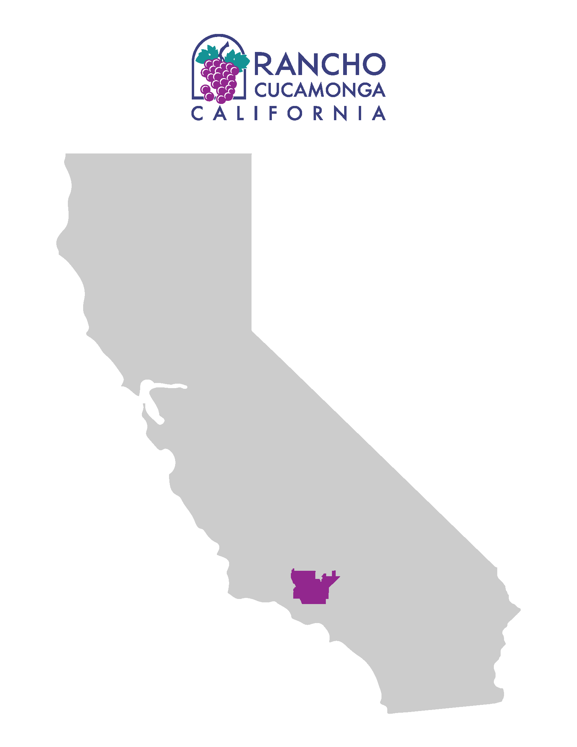

PART I: Tell Your Community’s Story

Rancho Cucamonga was founded on the premise of bringing three established communities together - Alta Loma, Etiwanda, and Cucamonga. Local control of land use would safeguard the existing quality of life and ensure a bright and prosperous future for generations to come.
Although still a relatively young city, Rancho Cucamonga has experienced exponential population growth from 50,000 to over 175,000 residents since incorporation in 1977. The City prides itself as the “City with a Plan” and is renowned for its use of thoughtful planning policies and intentional development strategies to build neighborhoods that will remain vibrant for generations to come. City leadership ensured that residential and commercial expansion was balanced against retaining the City’s agricultural and equestrian heritage and desire for open spaces. Residential developments were conditioned to include spacious greenbelts, meandering trails, and accessible parks for fitness and enjoyment, creating highly coveted suburban neighborhoods.
Public-private partnerships have been leveraged to bolster cultural initiatives, such as the Lewis Family Playhouse and the Epicenter Sports Complex, which is home to the Rancho Cucamonga Quakes minor league baseball team, Goals Soccer Center, and the RC Sports Center. Attention was given to our fur-buddies with the establishment of the locally operated Rancho Cucamonga Animal Services Center which paved the way for programs such as the neonatal Kitten Nursery. Partnerships with established community organizations, such as the Alta Loma Riding Club, help balance the preservation of the City’s history with the ambitions of its future.
Thirty years ago, plans were made and land set aside for a 100-acre Central Park to be the centerpiece of the City’s active lifestyle. The developed 30-acres of the park is the home of the Senior and Community Center, providing daily programming for a broad range of ages, interests, and ethnicities. In the last three years, the City embarked on an update to the Central Park Master Plan, which included extensive community engagement to “ReVision” the remaining 70. Our residents included a state-of-the-art dog park, an outdoor amphitheater, and a public-private venture for a modern aquatic center as mainstays in the updated plan.
As highlighted by the projects in this application, community partnerships are the cornerstone for the successful growth of the city thus far. Residents are valued partners that are sought out for their ideas and solutions. We strive to stay humble and listen with intent as the community guides City leaders on their specific needs and priorities. We leverage the strength of non-profits and local businesses to drive change that will stick.
Our ambitions over the past five years have not been the creation of new policies and initiatives, but rather elevating civic engagement as a cultural foundation. We understand the accelerating importance of local government’s role in mending the social fabric and pursuing equity and access for our entire community. We continually pursue the truly American value of applying humility and passion towards serving the greater good and ensuring all residents benefit from being a part of the All-America City of Rancho Cucamonga.

PART II: Describe the Strength of Your Community’s Civic Infrastructure

In 2008, the City Council established the Healthy RC initiative with the ambition to fight the growing epidemic of childhood obesity. The Healthy RC program was established as a genuine partnership of City government, community agencies, and grass-roots residents who collectively identify their community’s health challenges and work collaboratively to address them. Little did we know that Healthy RC would not only become a catalyst for enhancing health and well-being throughout the entire city, but a model for authentic community engagement.
Healthy RC was envisioned as a comprehensive system of interconnected planning, program, policy, and partnership efforts that work across sectors to promote community health and equity. This approach engages stakeholders at all levels to achieve a collective impact on some of the community’s most serious health problems. It also empowers residents to self-advocate for the specific needs of their neighborhoods, promoting equity and access across City services.
Healthy RC works to institutionalize a culture of community care that withstands changes in broader political and economic conditions. The Healthy RC partnership has evolved from a small group of agencies to a broad community partnership with over 75 active resident champions representing various community organizations and public entities, committed to improving community health outcomes. These include residents, businesses, faith-based organizations, school districts, universities, hospitals, non-profits, and public agencies that meet on a monthly basis to put good health within reach of ALL residents. The Healthy RC Steering Committee, with representatives from these combined interests, was formed to provide continued oversight of the program. The ambition was to elevate local voices to create action towards improving access to healthy food, expand early education opportunities, implement safe active transportation, and express community pride through public art projects that embody the history and individuality of Rancho Cucamonga.
From the onset of the Healthy RC initiative, Rancho Cucamonga’s leadership was intentional in bringing diverse groups of residents and stakeholders to the table to build civic capital. To be effective, the City needed a comprehensive community engagement approach to better understand the health and well-being of our residents. Historically, local governments have been limited in their effectiveness at reaching marginalized communities. We recognized that any meaningful process would have its challenges and could be intimidating because it requires acknowledging deep community economic, racial, political, social, and cultural divisions. Despite this, we understood that without equitable and inclusive engagement there was a risk of making decisions that could have negative unintended consequences on vulnerable and under-resourced populations.
A year-long strategic planning process culminated in the Roadmap for a Healthy Future in Rancho Cucamonga. The process of developing the Roadmap was multi-faceted, community-driven, and designed to solicit input from all the diverse voices of Rancho Cucamonga. The Roadmap is the community’s plan, in every sense of the word, and includes a shared vision, values, goals, and strategies for ensuring that Rancho Cucamonga is a community where all generations lead vibrant, healthy, and happy lives. The community identified eight health priorities: Healthy Eating and Active Living, Community Connections and Safety, Education and Family Support, Mental Health, Economic Development, Clean Environment, Healthy Aging, and Disaster Resiliency.
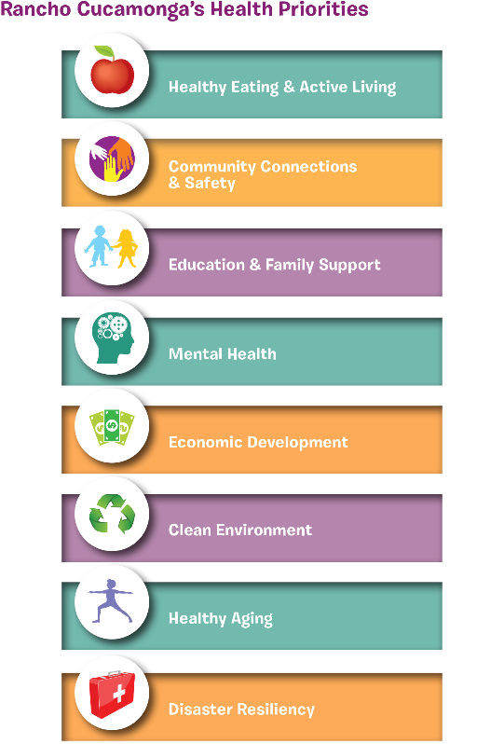
Hundreds of community members dedicated thousands of hours to design the planning process, share their ideas and priorities, analyze and interpret the data, and review, revise, and produce the plan. Ultimately, this outreach and subsequent plan illustrated that health is at the foundation of everything we do, and the City has since taken a “health in all policies” approach to its governance and service delivery.
We are proud to share that our outreach efforts reached one in five residents, representing over 32,000 people, through stakeholder meetings, key partner interviews, focus groups, in-person and online surveys, and a large community forum. Partners met residents where they are at – mobile home parks, senior housing and affordable housing complexes, schools, churches, parks, and even in their own homes. During the initial outreach, however, cultural and language barriers were identified as significant obstacles to reaching residents in predominantly Spanish speaking neighborhoods. As a result, Cucamonga residents were strikingly underrepresented in other civic activities and community meetings, and particularly in local government policymaking processes.
City staff reflected on residents’ experiences and imagined what it would be like to be a non-English speaker receiving an invitation to a City meeting, in a foreign language, at an unfamiliar facility, and by a government that had never particularly included them. On top of these barriers, were the usual challenges of transportation, childcare and having the extra time to actively engage in civic matters. These realizations inspired the City to transform their “one-size-fits-all” community engagement approach to one that is centered on inclusivity, empowerment, and authenticity.
Establishing trust among residents meant enlisting bilingual City staff in building genuine relationships with individual community members who were invested in reshaping their neighborhood. It meant the City needed to be vulnerable and acknowledge the historical inequities while being open to new ideas and ways of doing things. As a result, the City fostered the development of two leadership programs focused on empowering Cucamonga residents to share their voice with the rest of the City: Campeones para la Comunidad and Healthy RC Youth Leaders.
Campeones para la Comunidad and Youth Leaders meet bi-weekly and have been major players in Healthy RC’s efforts to improve conditions in Cucamonga neighborhoods. They conducted walkability assessments, resulting in a grant to install sidewalks along school routes in Cucamonga. The Youth Leaders surveyed their peers at local high schools and conducted taste tests, leading to the City’s adoption of a healthy nutrition and beverage standards policy. The Campeones helped craft language for the City’s farmers market ordinance and were the primary architects of the Bringing Health Home, a farmers market voucher program. Both groups canvassed their neighborhoods, collecting data that informed the development of our complete streets policy and our Circulation Master Plan, which, due to the involvement of the Campeones and Youth Leaders, places a priority on making Cucamonga neighborhoods bicycle and pedestrian friendly.
The Campeones and Youth Leaders also led the community process for designing and naming Los Amigos Park, which brought a long-needed, beautiful space for families in Cucamonga to enjoy being physically active. Both groups are frequent speakers at City Council meetings in support of healthy policies and at regional, state, and national conferences sharing their experiences and best practices with other communities. We have come a long way since that first community forum when residents felt unable to make meaningful changes, to today when many of those same residents are the leaders and change agents not just in their neighborhoods, but in citywide projects, like the discussion to annex 4,000 acres into the city with the Etiwanda Heights Neighborhood and Conservation Plan.
Reflecting on her time as a member of the Campeones since 2010, Barbara Milenez stated,
“Nuestras calles son más seguras, nuestras familias son más saludables y nuestras vidas están más llenas gracias al trabajo que hemos realizado a lo largo de los años.”
Maelin Aquino, one of the Healthy RC Youth Leaders, identified the most important aspect of our success when she said,
“Although many things have made Healthy RC successful, we think it works because we are the ones who live here, and we are the ones coming up with ideas and doing what it takes to make our community healthier.”
Maelin’s statement captures our approach to ensure that good health is within reach of everyone, and that those most affected by poor health have a voice and meaningful role to play in creating solutions that fit their culture and neighborhoods.
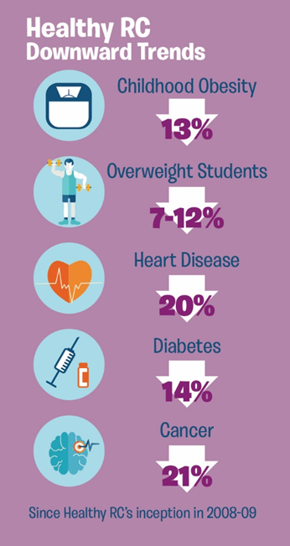
In 2017 Healthy RC went through a comprehensive evaluation of the initiative. The results showed positive effects at multiple levels:
- Population Health – reductions in obesity rates, heart disease, suicide, traffic crashes, and asthma
- Healthy Behaviors – physical activity, nutrition, community connections, engagement, and empowerment increased
- Collaboration – shared vision, inclusion at all levels, meaningful and deep relationships, and impacts on health and wellness of the community
Moreover, the success of Healthy RC paved the road for expanded authentic and inclusive community engagement to become part of Rancho Cucamonga’s civic DNA. Using the lessons learned engaging with the community over the last twelve years, we are developing a citywide community engagement policy with a health equity lens to provide a roadmap to staff in all City departments to have the tools to design and deliver services that meet the needs of all the communities it serves. At the core is a framework that provides the City with systematic approaches to developing partnerships with diverse communities which will ensure diverse ideas and perspectives are included in shaping public policies, practices, projects, and services moving forward.

PART III: Describe Three Community-Driven Projects

PROJECT ONE
The Challenge
After the City’s incorporation, Alta Loma and Etiwanda seemed to prosper immediately with increasingly expensive homes and new special financing districts to ensure neighborhoods reflected the City’s world-class community ambitions. The predominantly Latino community of Cucamonga faced growing barriers to accessing the healthy lifestyle the rest of Rancho Cucamonga enjoyed. Early data revealed two out of every three residents in this area were obese or overweight and three out of every four school children did not meet fitness standards. There were no outlets for selling fresh produce, limited access to open spaces for exercise, and streets lacked curbs, sidewalks, and bike lanes for active transportation.
In the initial Healthy RC assessments, Cucamonga was identified as a park-poor neighborhood. The award of a $3.9 million State grant in 2010 provided the opportunity to build an approximate 3.4-acre park on a site owned by the City’s Redevelopment Agency. The site consisted of a flat, open area with small, vacant houses in poor condition. The area was fenced for security purposes and had become a blighted eyesore for residents and served as a constant reminder of the safety risks that affected their community. With the dissolution of redevelopment agencies in California, it took the City over four years to navigate the State’s lengthy approval process to transfer the property to the City in order to start the process of making the dream of a park a reality.
Actions Taken
This park was to be built for the community, by the community. Beginning in 2015, a tailored approach to engagement was vital to reach this unique population that historically did not trust local government due to the lack of progress they had experienced in their neighborhood. Since the majority of the population in Cucamonga is bilingual, all materials including mailers, social media posts and online information were translated to Spanish. To eliminate barriers to engagement, design workshops were led by bilingual staff and held at various locations, days, and times to alleviate accessibility and scheduling issues for working families. Community partners donated food so families could attend evening meetings without sacrificing dinner, and staff provided childcare to attendees.
News of civic collaborations and outreach for resident input continued to spread by word of mouth throughout the community. Slowly but surely, trust began to build between the City staff and Cucamonga residents, strengthening the vital relationships needed for future growth and success. Residents began to feel that their opinion mattered to the City. They realized the City wasn’t just there to simply build a park for them, but to build it with them. One Cucamonga resident shared,
“I was skeptical when I first heard the City was seeking our input, but that quickly changed when they continued to show up and ask for input every step of the way!”
To create a park tailored to the Cucamonga community, staff intentionally engaged children and families. At one workshop, the children from Los Amigos Elementary School helped create an art mural: a tree whose leaves were made from the children’s handprints. This was later used as the park’s logo and continues to be a symbol of generational pride in the community. In another workshop, students were asked, “What does friendship mean to you?” and were given art supplies and paper to illustrate their values of friendship. Over 80 pieces of artwork were transformed into ceramic tiles, and later mounted on the faces of two freestanding walls at the center of the park. Parents were empowered to provide input on the layout of the park and emphasized the importance of safety and visibility. Park needs, amenities, and even the park name were all determined during these collaborative workshops. The resulting final design included a skate park, basketball court, playground, water misters, and outdoor fitness equipment donated by a regional health care partner, Inland Empire Health Plan (IEHP).
Long time Cucamonga resident Johanna Morales expressed her hopes for the project stating,
“For months my two daughters would stare out the window watching the progress of Los Amigos Park. They were so happy to see our ideas actually implemented, and that meant the world to them!”
At the park’s dedication, residents were finally able to experience and enjoy the park they envisioned, designed, and helped bring to life.
Los Amigos Park was not the only infrastructure project driven by the Cucamonga community. Candid conversations with residents shed light on deeper and more pervasive safety issues such as gang affiliated street corners, transients, aggressive dogs, and incomplete sidewalks forcing children and families to walk in the street alongside speeding cars. Motivated to address the missing sidewalks and bike lanes, members of Campeones para la Comunidad took photos, and created a photo-voice project of issue areas and submitted the data for a federal Safe Routes to School (SRTS) Grant Application. Using this grassroots approach to solving community issues, the City was awarded funds for infrastructure enhancements, as well as educational programming for the nearby school. Together, the Campeones worked alongside the City’s Engineering, Planning, Public Works, and Police Departments, to identify strategies to improve Cucamonga’s existing environment by identifying the safest routes in Cucamonga for the community to use, whether they were going to the park or school.
This initiative improved the network of sidewalks and bike lanes throughout the Cucamonga neighborhood and helped bridge collaboration between the community and the local government agencies that serve them. To ensure sustainability of these improvements, SRTS was also adopted by Los Amigos Elementary School to empower students, teachers and families to be the eyes, ears, and advocates for their environment. Just like the Campeones, students, teachers and parents participate in walk audits and work alongside City engineers, planners, and public works staff to continually improve the connectivity of their built environment and safety in their community.
“We were so excited to have the park, a playground like this is so important in making a habit of a healthy lifestyle,” said Los Amigos Principal Amber Arreguin, “and now with the SRTS program, we can ensure the safety of our children who walk to and from.”
For a unique population like Cucamonga, one that historically was not engaged, the City wanted to do more than build the park and improve infrastructure. The City wanted to solidify its commitment to Cucamonga and strengthen neighborhood comradery and cohesiveness. CommUNITY Paint Day, an intersection repair project, was a culmination of direct collaboration between Los Amigos Elementary School, neighborhood residents, community partners, Healthy RC, and City staff. Healthy RC hosted multiple community meetings at Los Amigos Elementary School to give residents and students the opportunity to voice their vision for the mural design. Janet Temkin, Superintendent of Cucamonga School District, reflected on the City's collaboration with the school and said,
"From the very beginning, our students were allowed the opportunity to participate in the engagement process to share their hopes, dreams and values in depicting a design for this project."
With the donated assistance of local artist Vincent Jimenez, community residents transformed an ordinary intersection in front of Los Amigos Elementary School into a vibrant public space, bringing the community’s vision of unity and diversity to life.
In addition to providing neighborhood residents, students, teachers and community members the opportunity to paint the mural onto the intersection, individuals also enjoyed many festivities that were offered at the CommUNITY Paint Day. Musical entertainment was provided, kids from the community enjoyed face painting, a bike rodeo promoted bicycle and pedestrian safety, and a cooking demonstration helped to promote healthy eating.
“When you have children creating, designing and painting the mural, there is joy. That is something that will stick in their heart, and stick in their soul, and they will remember that Los Amigos is vibrant, welcoming, diverse and it is the place they call home.” – Nanette Hart, parent at Los Amigos
With these infrastructure improvements came complimentary programming to the Cucamonga area. Los Amigos Elementary School, the heart of Cucamonga, became the site of the City’s first “Community School”, with an integrated focus on academics, health and social services, community development, and community engagement which leads to improved student learning, stronger families, and healthier communities.
“Using a Community Schools Model, we are looking at the whole child because that’s what ensures academic growth and physical and emotional wellbeing.” – Victoria Rigney, Vice Principal at Los Amigos
Los Amigos Elementary continues to serve as a hub for community engagement. Bringing Health Home and Cocinando Amigos Saludable y Alegre (CASA), a healthy cooking class, address the lack of knowledge and access to healthy food in the area. Partnerships with local nonprofits and businesses provide extra support to students and families. Healthy RC partner and local nonprofit, Women on the Move, provides afterschool mentoring for 5th grade girls. In addition, local mental health professionals volunteer their time providing bilingual seminars on mental health topics for parents. The City was awarded a grant from Kaiser Permanente to implement the Your Mind Matters: A Mindfulness in Schools Curriculum schoolwide to address the most prevalent mental health issues such as bullying, trauma, stress, and resiliency among the students and staff. Students and teachers practice mindfulness daily, using different techniques such as breathing and stretching. Since the program’s implementation, students have demonstrated improved attention spans in the classroom, emotional regulation, and a decrease in stress/anxiety.
Outcomes
The collaboration to build Los Amigos Park started the transformation of Cucamonga, leading to continued community driven projects that bring the amenities of a modern city while respecting local heritage. The City has invested over $11 million towards infrastructure improvement in the Cucamonga neighborhood, with additional projects planned as funding becomes available. A parent at Los Amigos commented on the positive impact these partnerships have had and shared:
“We’ve all learned that our voices are important and can be heard and they can be a part of something greater in the community by working together!”
Blight and poverty are not acceptable conditions for any neighborhood; they can be products of neglect and avoidance. Whether conscious or not, when cities neglect conditions of economic and social disadvantage the effects can ripple through generations. The term All-America City directly implies the idea of unbiased inclusion for every member of the community. It signifies how we are truly better together and highlights the American value where we continually strive to overcome injustice and inequity. We don’t run from difficult conversations and we don’t turn our backs on anyone in our community. We lean in to making things right and earn back trust by empowering through respect and action.

Primary Contact:
Hope Velarde, Management Analyst
City of Rancho Cucamonga
Hope.Velarde@CityofRC.us
(909) 774-2007

PROJECT TWO

The Challenge
Within the first two weeks of the 2018 school year, four Rancho Cucamonga students committed suicide. The first was a ten-year old, followed by three high school students. A wave of confusion and pain enveloped the entire city as we grappled with the news. This devastating period left students and parents seeking emotional and psychological support. Through the heartache and grief, these events highlighted the urgent need for community intervention and galvanized support for programs to destigmatize mental health issues and focus on suicide prevention.
To further understand mental health on a community-wide scale, Healthy RC conducted a comprehensive Quality of Life survey which indicated that over half (57%) of the respondents who acknowledged a need for help (emotional, mental health, or substance abuse) did not seek it. Healthy RC also conducted a Teen Quality of Life survey across high school campuses and the results were alarming. One in three teens reported that they have attempted to harm themselves. Teens were also hesitant to seek mental health services with 30% of respondents reporting they did not seek out support when needing it. Like many communities throughout the nation, our residents face seemingly overwhelming barriers when seeking mental health services, including cultural and generational stigmas.
Actions Taken
Our community was unafraid to shed light on taboo topics such as anxiety, stress, depression, and substance abuse. The more individuals shared, the more the City realized the need for a cultural shift on the subject of mental wellbeing. We realized new strategies were needed that push the boundaries of how cities traditionally serve their residents.
In response to this critical need, Healthy RC formed a Mental Health Subcommittee with the goal of creating platforms for community members to engage in meaningful conversations on mental health issues. Since 2015, the Mental Health Subcommittee has been developing strategies to address and inform mental health challenges. Key members include City departments, San Bernardino County Department of Behavioral Health, Inland Empire United Way, Women on the Move Network, San Antonio Regional Hospital, local mental health professionals, faith-based organizations, and city residents of all ages. In parallel with the City’s efforts, the Chaffey Joint Union High School District also developed a Mental Health Task Force (counselors, therapists, teachers, nurses, students, City and County representatives) to further address strategies for connecting resources in the schools and establishing cross–sector collaboration.
“A lot of organizations have been working on this for a long time. It has not been as effective because they are working within their silos. Healthy RC broke down those barriers to include hospitals, city and county entities, non-profits, and mental health service providers. We’re starting to collaborate to make a bigger impact on providing mental health resources” –Healthy RC non-profit partner, James Scheu (NLab Solutions).
The Mental Health Subcommittee used a variety of inclusive strategies to increase awareness and access to culturally appropriate mental health services and reduce the stigma associated with mental health. The Subcommittee developed and disseminated a bilingual Your Mind Matters (YMM) digital and print campaign that targeted all segments of the community. The materials encourage residents to “Start the Conversation” and direct residents to HealthyRC.com, which features an extensive list of local mental health resources. Developing Spanish content was challenging as some mental health terms do not readily translate from English; however, we overcame this challenge by reviewing the content with Campeones para la Communidad to ensure cultural relatability. The materials were distributed across all neighborhoods, schools, community centers, churches, libraries, local events, and through social media. The reach of this campaign exceeded over 200,000 people.
In the wake of the 2018 suicides, Healthy RC Youth Leaders used their personal experiences to develop a series of mental health awareness videos for the YMM campaign. The teens’ videos focused on providing support for prevalent community issues and highlighted 24-hour hotline resources. Their bilingual and culturally relevant La Ropa Sucia suicide prevention video was awarded first place in a statewide mental health video contest.
“When someone is on a trajectory to completing a suicide, having one person interact with them to make them feel as if they really matter, is a game changer.” - Youth Leader Brynn Barker
Youth Leaders also stressed the need for teens to have a safe gathering space to discuss stressors and life experiences with their peers. They worked with City staff to create an annual Teen Summit to empower high school students and provide them with a platform to be heard in a safe space, to connect with mental health resources, and to listen to motivational speakers share about overcoming challenges such as bullying, depression, suicidal ideation, and resilience. Over 250 teens across the city attended the 2018 and 2019 Teen Summit events and left with impactful moments, memories, and much needed coping skills and resources. Briesa Vasquez, high school senior, shared,
“The Teen Summit was a turning point in my depression because it made me realize I wasn’t alone. It made me feel that I had a place to talk to teens and relate to teens that are struggling.”
Healthy RC also hosts quarterly Community Conversations on Mental Health at community centers and schools, providing small group settings to help reduce barriers to mental health services. These free events serve as a direct connector for youth, parents, and families looking for a safe space to ask questions of mental health therapists, and hear informative presentations and panels about suicide prevention, cyberbullying, anxiety, stress management, and coping with grief and loss. At the symposia, therapists provided psycho-educational resources and support to families who may have been feeling lost and afraid, uncertain as to how to take that first big step when asking for help. Mindfulness activities like breathing exercises, tai chi, and meditation skills have been taught by experts, providing attendees with valuable coping tools. Small group discussions facilitated by mental health professionals, give neighbors a safe space to feel vulnerable and create community connections for talking openly about mental health. For many attendees, this is their first time engaging with a mental health provider and the impact these events have on the community is profound. Almost all surveyors from the stress management symposium (92%) agreed that as a result of the event, they now know how to create a self-care plan for themselves. 85% of surveyors felt empowered to teach others about self-care coping tools. Follow-up surveys indicate that after attending the event, 60% of the participants ended up seeking mental health services for themselves or for a loved one.
In addition, all five school districts have continued these community conversations by providing suicide prevention and Mental Health First Aid trainings to staff and workshops for students and parents. Churches are also hosting events and trainings. Ongoing support services are also now available at the City’s RC Family Resource Center, including a clothing closet, food pantry, substance abuse support groups, and mental health workshops. Additionally, the City has a leadership role on a regional committee ensuring dedicated services for the City’s homeless population, including their mental health needs.
Healthy RC partnered with Catholic Charities to host a Health Equity Summit in 2019 to help community leaders understand what it is like to physically cope with the chronic stress created by limited resources. Through family role-playing, over 150 diverse community participants experienced real-life challenges and explored how health equity impacts a community. Tu Brown, a participant from a local business shared,
“Struggling with food stamps, addiction, homelessness... I lived it. Playing it again, at this event it was stressful but it really made me see how far I have come, and I am hoping I will be able to help others.”
The Rancho Cucamonga Public Library (RCPL) also responded to the critical need for community mental health resources and had frontline staff certified as Mental Health First Aid instructors through the National Council of Behavioral Health. Staff learned to work effectively and compassionately with people experiencing mental health issues and connect them with local mental health resources. Library staff trained City employees, firefighters, nurses, and social workers, with the goal of reducing the stigma of mental health and expanding community resources. The Library also offers a weekly meditation class, led by a community resident, which teaches mindfulness as well as other mental health resiliency techniques.
The Library also surveyed their Teen Advisory Group (TAG) on their needs and based on the results created a free “Adult 101” series to provide additional resources for teens to develop life skills such as college and job preparation, adult paperwork (registering to vote, understanding credit, health insurance, etc.), time and stress management, and to recognize mental health triggers and develop coping tools. Throughout the series, teens were able to have a trusted safe space to openly share their fears about the future, hear from a therapist, and learn tangible life skills.
RC Kits are an ancillary mental health resource created as a direct response to the TAG survey results. There are 22 unique kits equipped with tools, supplies and books on various topics including: Astronomy, Dance, Organization and Planning, Photography, Yoga and Meditation. RC Kits have been well received by residents as a free mental health resource and serve as coping mechanisms for residents to bring joy and happiness in their lives. A user of the “Organization Kit” said,
“This kit comes with a lot of helpful activities and information, when applied they will have a major impact in anyone’s life. I felt like this kit would be a good place to start or begin taking control of my life again.”
Since its launch in the summer of 2019, these kits have been in popular demand, with more than 250 borrowers so far and a typical waiting list of 13 people per kit.
Outcomes
The confusion and pain from the Fall of 2018 has given way to the resolve and commitment to ensure mental health and well-being remains a priority for the entire community. The City continues to build on its foundation for encouraging residents to be active participants in the ongoing process of safeguarding their community. Over the past 5 years, the community has undergone a cultural shift as we continue to enhance awareness and access to mental health services. Although conversations on mental health are neither easy nor comfortable, the alternative is unacceptable. We have committed to providing every resource available to avert any further tragedies.
Preventing further tragedies requires a multi-pronged approach to ensure the message of caring is pervasive among diverse populations. A compassionate community is probably one of the best outcomes we could have hoped for because a community where compassion is fully alive is ultimately a thriving and resilient community. Healthy RC’s Compassionate Community initiative has brought compassion and kindness to life in practical ways through the #BeKindRC campaign and has inspired a culture of caring. The words of Healthy RC Youth Leader, Gia Chinchilla, at one of the City’s first mental health forums continues to ring true today,
“A lot of people just go day by day...they don’t feel needed, feel wanted, or feel important...but we need to show them that they are and that our community cares.”
This sentiment resulted in an extremely moving and inspirational video featuring resident testimonials of their mental health journeys and continues to offer a renewed sense of purpose and hope.
One unexpected outcome of the City’s mental health work is the realization that urban design holds exciting potential for community mental health. Urban design can help promote good mental health, help prevent mental illness, and help support people with mental health problems. Access to natural settings and greenspace in neighborhoods and in the course of people’s daily routines promotes exercise and provides a setting for social interaction and building social networks. The City took the opportunity for urban planners, developers, and policymakers to integrate these strategies into project requirements and project design in the Etiwanda Heights Neighborhood and Conservation Plan.

Primary Contact:
Joanna Marrufo, Management Aide
City of Rancho Cucamonga
Joanna.Marrufo@CityofRC.us
(909) 774-2044

PROJECT THREE

The Challenge
When Rancho Cucamonga incorporated in 1977, one of the community’s main objectives was to ensure its own destiny through local control of land use. At the time, the area was growing quickly, and under the authority of the County, growth was outpacing the ability of the local schools, parks, and infrastructure to provide service. In the City’s first General Plan, the community stated its aspiration to conserve approximately 4,000 acres of land with a series of rural neighborhoods and open space located in the foothills, just outside the City limits. Over the course of three decades, the City made several unsuccessful attempts to annex this land and secure its future. In the meantime, the community watched as gravel was extracted from this land, where a rock quarry had begun to scar the natural landscape north of the City.
Actions Taken
In 2015, the gravel mine closed. The County put up the 4000 acres of quarry and surrounding land for sale, making it available for development. This created an opportunity for the City to partner with the County to annex the land. For 18 months, the City’s Planning Department worked with the County, resource agencies, and select community stakeholders to understand the potential of transforming a brownfield mining site into a series of healthy, walkable neighborhoods and thousands of acres of conservation.
In late 2017, the Planning Department’s consultants presented the plan to the community at a neighborhood meeting conducted near the former quarry and was intended to solicit feedback on the initial plan concept. Staff and consultants hoped the City’s effort would be appreciated and supported. To their surprise, the support and appreciation was absent. The community expressed disappointment with the lack of inclusion and felt the “City’s plan” was forcing new development upon them without their input.
After four contentious meetings, the City Council set aside the preliminary concepts and directed staff to improve their community outreach efforts. The results of the Fall 2017 process revealed that although a strong civic index had been built through the Healthy RC efforts, not all departments had the know-how to deploy these resources. Realizing this, the City pivoted and put together a cross-departmental team to focus on community engagement and create a close collaborative effort with the community to understand and establish a vision for the future of this vacant land.
Inclusivity became a priority in this second round of workshops. City staff began by bringing blank maps, representing a clean slate, to the table. Together, citizens and staff shared the responsibility of crafting a strategy to develop the quarry into desired neighborhoods while preserving the natural elements of the foothills for future generations. These efforts helped reshape the relationship between the community and its civic leaders. In addition to the large workshops, the City also engaged the community through small focused group meetings, and personal and online surveys. Throughout the spring, many of the community participants continually supported local control and a form of neighborhood development that would enhance their city. Surveys and analyses of community input consistently indicated over 70% of the community favored and supported the vision for the conservation of the foothills.
Although impacts of the potential annexation would affect the entire community, we quickly realized that we had little engagement from residents who lived the furthest away from the annexation area in Cucamonga. Wanting the broad ideas and insights from the entire city, sought engagement with Campeones para la Comunidad, the Healthy RC Steering Committee, and Healthy RC Youth Leaders who articulated a myriad of concerns and desires. Furthermore, these groups then encouraged their networks to participate in the public input process which brought unique communities and perspectives to the table.
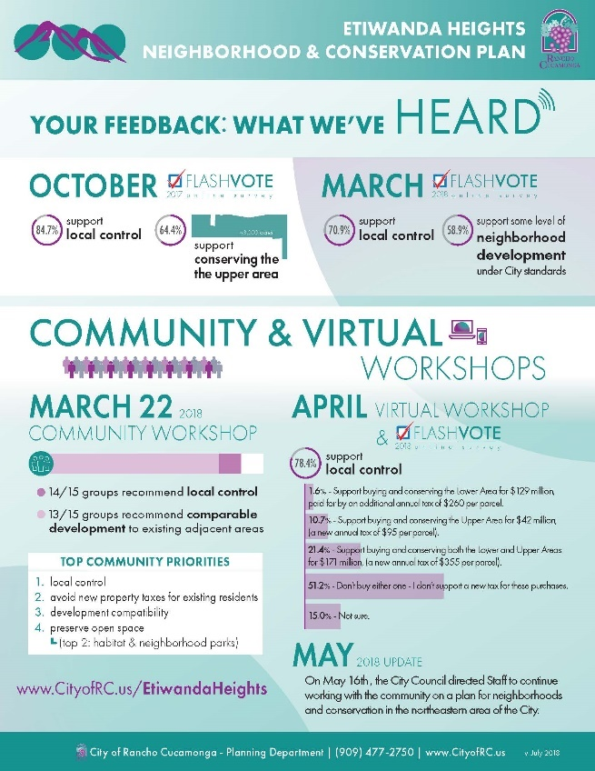
As the combined effort gained momentum, a name was established for the revamped specific plan: “Etiwanda Heights Neighborhood & Conservation Plan”. The name reflected the community’s priorities for conservation in the rural northern portion of the annex area and appropriate development in the southern portion located between two large existing residential neighborhoods.
Throughout the Summer of 2018, we embarked on further engagement, in both English and Spanish, with the community, focusing on “meeting the community where they are at” and continuing to work closely with residents, employees, visitors, and students to create a community-based plan that was grounded in the community’s values. That summer, the we hosted nine pop-up outreach events engaging with over 800 community members.
As the City continued its engagement efforts, it wrestled with the fact that many community members did not have time to participate in traditional meetings. Additionally, many young adults and teenagers are more comfortable participating virtually. In response, an innovative approach to outreach was introduced through social media and other digital communication platforms to inform and engage additional community members. Virtual workshops, surveys, and other digital engagement events were held to ensure that all residents were able to receive information, ask questions, and provide feedback. Using various digital survey tools, over 200,000 digital impressions were tallied with a reach of nearly 89,000 individuals. Through the use of these online engagement tools, community members suggested and selected a name for the main park corridor running through Etiwanda Heights. Based on the results “Camino de las Alturas” became the choice of the people.
As summer drew to a close, the City hosted an open house to share all the concepts based on the input gathered for the Etiwanda Heights Neighborhood & Conservation Plan. The open house was held in a City plaza and attracted over 200 people. Over the course of the event, City staff, technical consultants, and community members discussed alternatives for the foothills.
In the winter of 2019, the City released the public draft of the Etiwanda Heights Neighborhood and Conservation Plan and a draft Environmental Impact Report to begin another round of public input. Finally, after more than four years of work, the City Council adopted the Final Plan. At this meeting, Manuela Amaya stated,

“Estoy aquí esta noche para apoyar el plan de Etiwanda Heights. Aprecio la voluntad de la Ciudad de asistir a las reuniones de la comunidad para obtener nuestra opinión sobre el plan. Vinieron a nuestras reuniones de Campeones para la comunidad e hicieron su alcance en español y se aseguraron de que nuestra comunidad que hablan español estuviera representada en el proceso. Significa tanto para mí que este plan incluía la opinión de mi comunidad. Muestra que la ciudad realmente se preocupa por lo que tenemos que decir."
The Etiwanda Heights Neighborhood and Conservation Plan articulates a vision for extensive conservation of the foothills and alluvial fans that border the City to the north. The plan is further enabled by high quality, complete, walkable neighborhoods that reflect the rural history of Etiwanda and provide a range of housing opportunities to the south. The Plan is organized around the community-generated guiding principles, which were critical guideposts to arriving at the right balance of uses, densities, amenities, and preferred approach.
The result is a Community Plan to build a new healthy community while conserving over 3,600 acres, roughly 82% of the land, in the proposed annexation area adjacent to the San Bernardino National Forest. The 3,600 acres of proposed Rural/Conservation balance property rights, public safety, and conservation by providing a mix of conserved habitat mitigation lands and open space, existing open space preserves, and very low-density rural homesteads – all as a result of the extensive public input received as a part the engagement process.
The conservation strategy is fiscally underwritten by, and in balance with, high quality neighborhood development in an area already surrounded by existing neighborhoods. The neighborhood area is devised to ensure that both the conservation and neighborhood development pay their own way and without placing new tax burdens on existing residents. The new neighborhood area will spur the rehabilitation of the former mine site into a series of new, healthy, walkable neighborhoods with a strong mix of housing opportunities for family of many ages, incomes, sizes, and lifestyles. The plan will also provide up to 3,000 additional homes in a state that is continually struggling to meet its housing demands.
“My interest was in seeing that this project wasn’t something that would be million-dollar homes but would incorporate a range of housing options for all our local citizens to have opportunities. I was pleased to see it was a #3 priority on their plan – I thank planning for all they’ve done to engage community input and participation and that we move forward with much needed housing options within this community.” - Don Smith, Creating Community Solutions, a non-profit organization
The new neighborhoods will be centered around a small “Main Street” shopping area that will provide shopping and dining opportunities within walking and biking distance of the homes. This retail area is designed for mom and pop / single proprietor opportunities to allow owners to live close to where they work and play. The new neighborhoods will also include a new K-8 school, 85 acres of parks, and 11 miles of new trails that extend the City’s pedestrian, bicycle and equestrian trail networks to connect existing and new neighborhoods to one another and to the foothill open spaces above. Every home will be within a two- to four-minute walk of a park or trail. The emphasis on the design for people and improved accessibility is expected to reduce residents’ dependence on automobiles. Initial analysis shows that these new neighborhoods will generate 19% less traffic than surrounding neighborhoods.
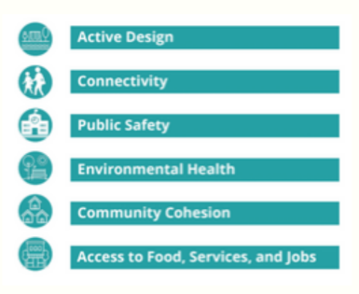
Healthy living is a crucial guiding principle of the Plan, and any future development in the Etiwanda Heights Neighborhood will meet the elements of the Healthy Development Checklist created by the Riverside University Health System - Public Health: Active Design, Connectivity, Public Safety, Environmental Health, Community Cohesion, and Access to Food, Services, and Jobs. The Vision for Etiwanda Heights addresses each of these healthy living principles with strengths and amenities uniquely derived from its location.
Outcomes
While the plan is impressive, the biggest impact was the change in how the City engages with the community on planning and development related issues. We learned that not only is the community appreciative of participating in these discussions, but that the community’s input can help improve the quality and success of land use proposals. Since the spring of 2018, the City’s community development departments have started a consistent, continual effort to engage with the residents in a more collaborative partnership in crafting the future of the City, based on the newly documented Community Engagement Plan.
As Rancho Cucamonga ages, we are continually adapting to the ever-changing landscape of civic service. Over the past decade we’ve learned important lessons on making community engagement a pervasive value and a starting place for all new initiatives. What started with Healthy RC’s ambition to bridge a divide in living conditions for one community evolved into a citywide conversation on the difficult topic of mental health and culminated in applying our new paradigm to the City’s last great development project.
Acknowledging our past and learning lessons for the next series of challenges is part of the journey of growth. All-America Cities are not the wealthiest or most affluent; they are the organizations most able to adapt and learn. They are willing to listen to their community with humility and authenticity. They are prepared to apply wisdom from experience to decisions being made for the future. The embodiment of this belief is shown in the projects we’ve described and the story we’ve presented and is what makes Rancho Cucamonga an All-America City.

Primary Contact:

Mike Smith, Principal Planner

City of Rancho Cucamonga

Michael.Smith@CityofRC.us

(909) 774-4317

Community Champions
“Our streets are safer, our families are healthier, and our lives are more fulfilled because of the work we have done over the years.”
Cooking Healthy and Cheerful Friends
Way/path to the Heights
“I am here tonight to support the Etiwanda Heights plan. I appreciate the City’s willingness to attend community meetings to get our input for the plan. They came to our Community Champions meetings and did their outreach in Spanish and made sure our Spanish-speaking community was represented in the process. It means so much to me that this plan included the opinion of my community. It shows the City truly cares about what we have to say.”

