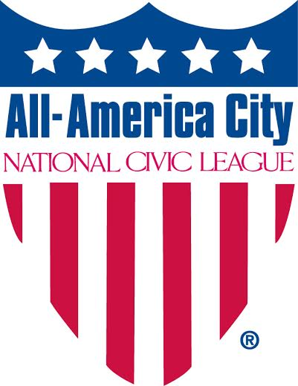
National Civic League
Sustaining Membership
OFFICERS
Mayor David Sander, Chair
Derek Okubo, Vice Chair
Lee Feldman, Treasurer
Alberto Olivas, Secretary
Doug Linkhart, President

DIRECTORS
James Cloar
Hon. Brad Cole
Reyna Farrales
Dr. Jarvis Hall
Mayor Steve Hogan
Hon. Glenda Hood
Valerie Lemmie
Hon. Ron Loveridge
Maureen McDonald
Terry Minger
David Palmer
Angela Romans
Cindy Steinhauser
Hon. Angel Tavares
Dr. Lyle Wray

FORMER BOARD CHAIRS
Mayor Michael B. Hancock (12-15)
Hon. Sandra Freedman (08-12)
Robert Rawson, Jr. (‘04-‘07)
Dorothy S. Ridings (’01--04)
Dr. David Mathews (’00)
Hon. R. Scott Fosler (’98-‘00)
Hon. Bill Bradley (‘96-’98)
Hon. John Gardner (’94-’96)
Hon. George Latimer (‘93)
Hon. Henry G. Cisneros (‘89-’92)
Hon. William F. Winter (‘88-’89,’ 93)
Terrell Blodgett (‘87-’88)
Hon. William W. Scranton (‘70-’73)

NATIONAL CIVIC LEAGUE
National Headquarters

190 East 9th Avenue #200

Denver, CO 80203
Tel.: (303) 571-4343
FAX: (888) 314-6053
ncl@ncl.org
www.nationalcivicleague.org

Since 1894, when a young Teddy Roosevelt and other reformers founded the organization, the National Civic League has been at the forefront of efforts to make local governments more open, accountable and effective.

The mission of the National Civic League is to advance good governance and civic engagement to create inclusive, thriving communities.

We achieve this by inspiring, supporting and recognizing equitable approaches to community decision-making. NCL applies civic engagement principles through four key programs: Racial Equity and Healing, Education and Youth, Environmental Sustainability and Health Equity.

Sustaining Members are critical investors in NCL’s work, donating $2,500 or more to help us strengthen governance and civic engagement across the nation. By becoming a Sustaining Member of NCL you are helping to support our efforts on such critical issues as: racial equity, environmental sustainability, youth success, and health equity.

Membership Benefits
In addition to supporting NCL’s important work, Sustaining Members receive valuable membership benefits including:

- Recognition in the National Civic Review. We will recognize your support on the inside cover of our quarterly journal for a year.
- Recognition on our website and in our monthly e-newsletter and social media, which have reach around 10,000 readers
- Free NCL staff consultations on matters related to civic engagement (New for 2016!)
- 15% discount on NCL’s strategic planning fees
- Access to All-America City Promising Practice Database: an online, searchable database of 450+ projects from more than 180 communities
- Free copies of NCL publications: including the Model City Charter, National Civic Review and Civic Index
- Permission to use our logo on your site identifying you or your group as a Sustaining Member of National Civic League.
- Opportunity to participate in our monthly All-America Innovations conference calls, which feature speakers from cities implementing creative strategies for civic engagement.

Support the National Civic League
Name:
Organization/Community (if applicable)
Address:
City: |  | ST: | ZIP:
Email:
Phone:
- I want to be a sustaining member of the National Civic League!
MEMBERSHIP LEVEL
Sustaining member - $2,500
PAYMENT INFORMATION
Check | Enclosed in a check payable to National Civic League for the amount of $
Credit Card | Please bill $ (amount) to my Visa MasterCard Amex
Credit Card Number
Expiration Date:

Signature: ________________________________________________________________________________

Mail check/form to National Civic League: 190 E 9th Ave, Suite 200, Denver, Colorado 80203. or fax to 1-888-314-6053.
Contact: Sue Lawson Gonzales at 303-571-4343, (suelg@ncl.org). For more information see www.nationalcivicleague.org.
NOTE: (NCL Tax ID 84-1255845) The first $40 of memberships is NOT tax-deductible, any amount beyond $40 is deductible.
Donations and sponsorships are 100% tax deductible

